Literacy support worksheet answers

1.1 Scientists review the research of other scientists

Pages 2–3

Scientific research

1 Which scientist is called the ‘father of genetics’?

Gregor Mendel

2 What type of plant did Gregor Mendel study to discover genetics?

Pea plants

3 Name the two important principles Mendel identified that form the basis of genetics today.

Independent assortment and segregation

4 According to Mendel, we inherit our characteristics or traits in pairs of factors, or genes. Where do we get these from?

One factor comes from our mother and one factor comes from our father.

5 Why do people call George Mendel the ‘father of genetics’?

He is considered the father of genetics because all of our current knowledge and understanding has been developed from his work.

6 If you inherit your curly hair from your father, does this mean you will also inherit your father’s blue eyes? Give a reason for your answer.

No, just because you inherit curly hair from your father does not mean you will also inherit his blue eyes. This is because each factor is inherited independently of any other factor.

7 Connect the scientist with their contribution to genetics.

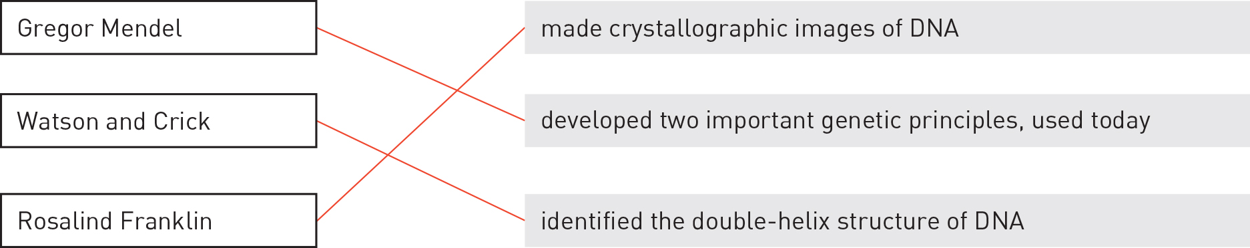

Word detective – Fill in the table

8 Gregor Mendel studied different traits of pea plants. Use the following word list to fill in the table below:

Word list: Round, Seed colour, Thin, Purple, Yellow, White, Pod colour, Green, Tall

|  |  |  |  |
| --- | --- | --- | --- |
| Characteristic | Example 1 | | Example 2 |
| Seed shape | | Round | Thin |
| Seed colour | | Yellow | Green |
| Flower colour | | Purple | White |
| Pod colour | | Green | Yellow |
| Stem height | | Tall | Short |

Literacy support worksheet answers

1.2 DNA consists of a sugar-phosphate backbone and four complementary nitrogen bases

Pages 4–5

The composition of DNA

1 Name the chemical that all genes are made up of.

DNA (deoxyribonucleic acid)

2 Where is DNA found?

In the nucleus of almost every cell in your body.

3 What kind of cell has no DNA?

Mature red blood cells

4 DNA is made up of nucleotides. What 3 building blocks make up a nucleotide?

A nitrogen base, a sugar molecule (deoxyribose) and a phosphate molecule

5 Label the three building blocks of a nucleotide on the diagram below.

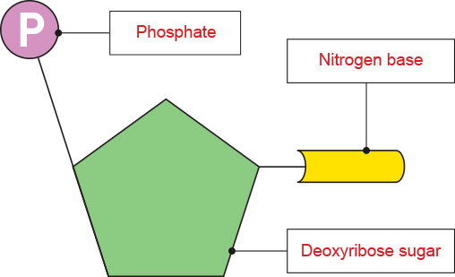

6 There are four nitrogen bases (listed below). Draw a line to match the base with its pair.

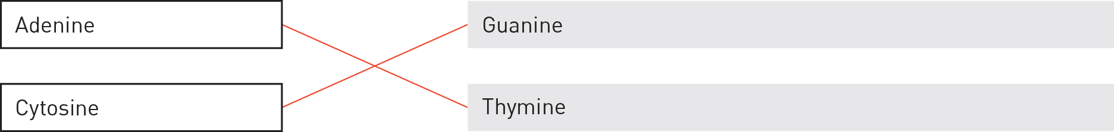

7 Describe the two vital roles of a DNA molecule.

DNA carries information – the sequence of bases within DNA codes for proteins.

DNA makes copies of itself (self-replication).

Word detective – Draw and label

8 Draw and label a diagram of a DNA double helix. Be sure to label the nitrogen bases. (Hint: You can use Figure 1.8 in the student book to help you.)

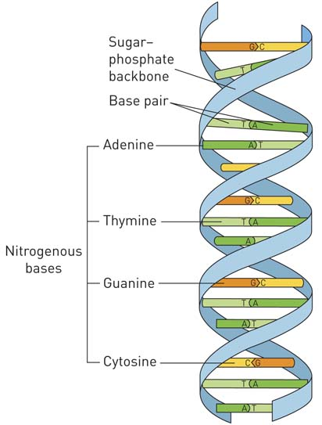

Literacy support worksheet answers

1.3 Chromosomes are DNA molecules carrying genetic information in the form of genes

Pages 6–9

Chromosomes

1 Which is larger, a gene or a chromosome?

A chromosome, which contains genes.

2 Circle the sex chromosomes shown in in the human karyotype below.

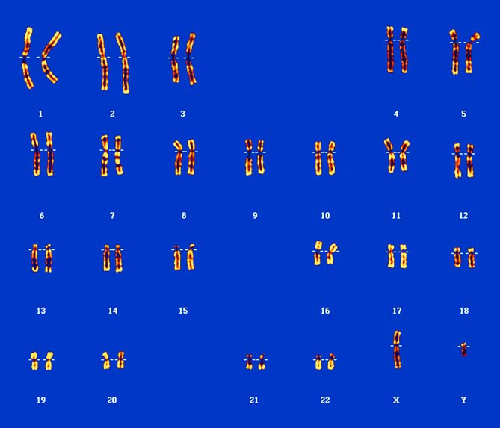

3 Is the karyotype above for a male or a female? How do you know?

For a male, as it shows one X chromosome and one Y chromosome. If it were for a female, there would be two X chromosomes.

4 What happens when a protein needs to be made?

The DNA unwinds to make complementary RNA. The RNA then makes a protein in the cell.

5 How many chromosomes do you inherit from your mother? From your father?

You inherit 23 chromosomes from your mother and 23 from your father.

6 Name the two processes shown in the diagram below.

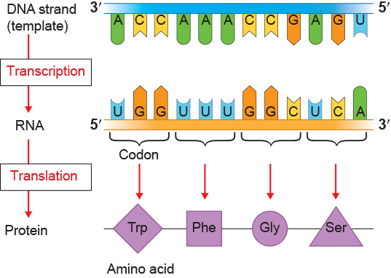

7 We have learnt that the following pairs of nitrogen bases always pair together:

Thymine (T) – Adenine (A) Guanine (G) – Cytosine (G)

Use the example in part a to help you complete part b below.

|  |  |  |  |
| --- | --- | --- | --- |
| a | DNA template: GAT ACC GCA TTC | b | DNA template: TAC GCC TCG ATT |
|  | RNA sequence: CUA UGG CGU AAG |  | RNA sequence: AUG CGG AGC UAA |

Word detective – Complete the Venn diagram

8 Complete the Venn diagram to compare the similarities and differences between DNA and RNA. The first key word has been completed for you.

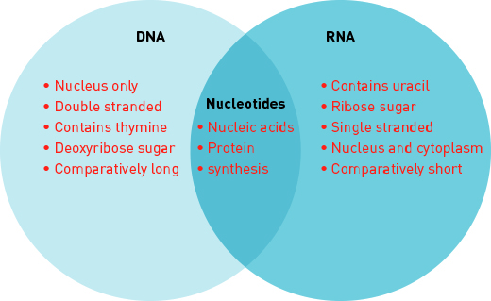

Literacy support worksheet answers

1.4 Mitosis forms new somatic cells

Pages 10–11

Mitosis

1 Match each term with the correct definition.

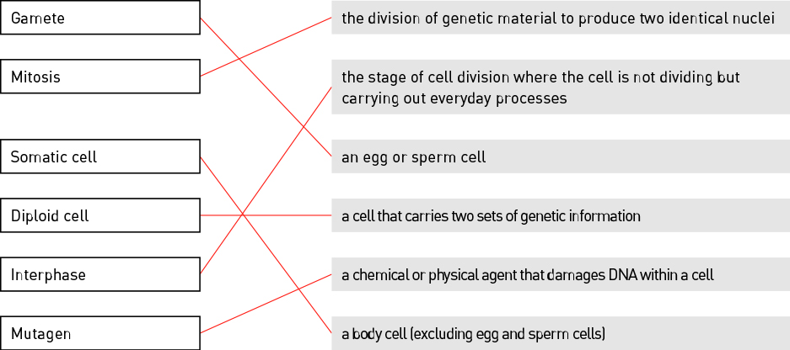

2 Name the cells in the body that do not undergo mitosis.

egg cells and sperm cells

3 Identify the stage of mitosis shown in the following image.

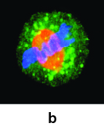

Metaphase

4 Complete the following sentence:

‘Mitosis is essential for an organism to grow and repair damage.’

5 If something goes wrong in a cell, programmed cell death occurs. What is this called?

Apoptosis

6 Name three ways the DNA of a cell can become damaged.

radiation, viruses, mutagens

7 Why is it that some cancer cells keep on dividing (mitosis) instead of dying (apoptosis)?

Cancerous cells have damaged DNA that has not been identified by the cell, and so it continues to divide (mitosis).

Word detective – Label the diagram

8 Label the stages of mitosis shown in the diagram below.

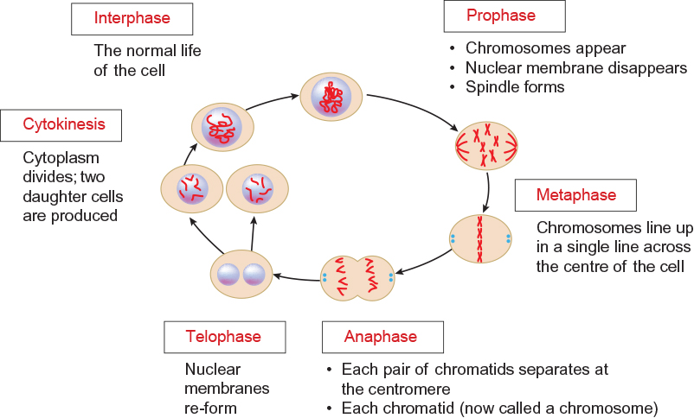

Literacy support worksheet answers

1.5 Meiosis forms gamete cells

Pages 12–13

Meiosis

1 What is a gamete cell?

Sex cells produced during meiosis

2 Use the following word list to fill in the blanks in the sentence below.

Word list: diploid, egg, chromosomes, mother

When the egg and sperm combine at fertilisation, a diploid somatic cell is produced – one set of 23 chromosomes comes from the mother and one from the father.

3 Circle the correct answer. A haploid gamete in a human, has:

a 46 chromosomes

b 23 chromosomes

4 Fill in the table below:

|  |  |  |
| --- | --- | --- |
| Organism | Male gamete | Female gamete |
| Humans | Sperm | Ovum |
| Plants | Pollen | Ovary |

5 Circle the correct answer to complete the sentence below.

‘In meiosis the number of chromosomes is\_\_\_\_\_\_\_\_\_\_.’

a halved

b doubled

c tripled

6 Meiosis only occurs in gametes, but mitosis only occurs in cells that are not gametes.

Complete the table below by writing whether meiosis or mitosis occurs in each cell type.

|  |  |
| --- | --- |
| Cell type | Type of cell division |
| Bone cell | Mitosis |
| Ovum | Meiosis |
| Guard cell | Mitosis |
| Skin cell | Mitosis |
| Sperm cell | Meiosis |

Word detective – Draw a flow diagram

7 Draw and label the process of meiosis.

Detail of labels will vary with ability of student but should include at least the name of each stage.

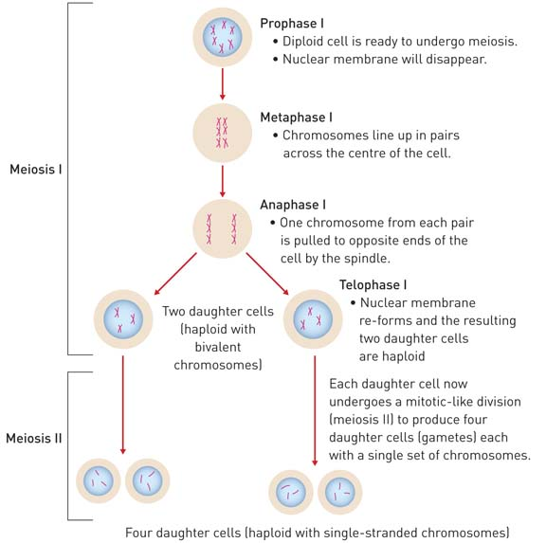

Literacy support worksheet answers

1.6 Alleles can produce dominant or recessive traits

Pages 14–15

Alleles

1 What is an allele?

The different versions of a gene

2 Fill in the blank to complete the sentence.

‘When there is a unique combination of alleles for a gene inherited from parents, it is called a genotype.’

3 The diagram below is of a pair of chromosomes and shows the alleles for hair colour.

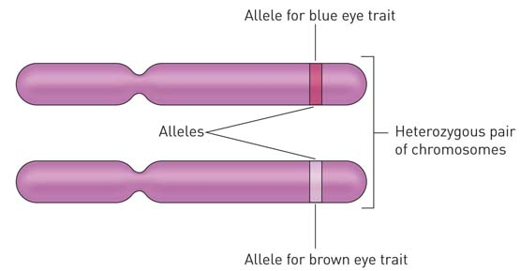

For eye colour (B) of this individual, determine:

a genotype: Bb

b phenotype: Brown eyes

4 Circle the correct answer to complete the sentence.

‘Homozygous individuals have\_\_\_\_\_\_\_\_\_\_\_.’

a two identical alleles

b two different alleles

5 Circle the correct answer to complete the sentence.

‘Recessive traits need\_\_\_\_\_\_\_\_\_\_\_.’

a two copies of the allele before it can be expressed

b one copy of the allele before it can be expressed

6 Give an example of a phenotype:

height

7 Attached earlobes (E) is dominant to unattached earlobes. Write down the possible genotypes of:

a attached earlobes: Ee or EE

b unattached earlobes: ee

c carriers: Ee

8 Right-handedness (H) is dominant to left-handedness. A right-handed man and a right-handed woman have two children that are both left-handed. Complete the Punnett square below and indicate how two right-handed parents can have two left-handed children.

|  |  |  |  |  |
| --- | --- | --- | --- | --- |
|  |  | Father | |  |
|  |  | **H** | **h** |  |
| Mother | **H** | HH | Hh |  |
| **h** | Hh | **hh** | There is a 25% chance of each child being left-handed. |

Word detective – Match the words

9 Match the traits to the gene combinations.

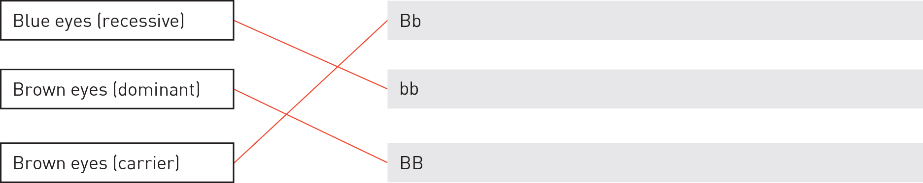

Literacy support worksheet answers

1.7 Alleles for blood group traits co-dominate

Pages 16–17

Co-dominant traits

1 What is the term used to describe both traits (AB) being expressed equally?

Co-dominance

2 What are the 2 components usually referred to when stating your blood type?

• Letter grouping

• Rhesus positive or Rhesus negative

3 Use the following word list to fill in the blanks in the sentence below.

Word list: marker, blood, red, Rhesus, negative, none

Rhesus markers are present on the surface of the red blood cells of 80% of people. If the Rhesus marker is not present on the red blood cells, the person is said to be Rhesus negative.

4 Which marker do people in blood group O have?

neither

5 List the 3 different alleles for ABO blood grouping.

IA, IB, i

6 Which ABO blood grouping allele is recessive and which alleles are co-dominant?

i is recessive; IA and IB are co-dominant

7 Emma has the genotype IAIB and Geoff has the genotype IAi.

a What is Emma’s phenotype? AB

b What is Geoff’s phenotype? A

c Draw a diagram in the space below to show how the surface of Emma’s red blood cells differ to those of Geoff’s.

Emma’s red blood cells:

Diagrams will vary. Example:

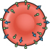

Geoff’s red blood cells:

Diagrams will vary. Example:

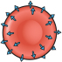

Word detective – Fill in the Punnett square

8 Fill in the Punnett square to show the possible combinations of genotypic ratios for Emma and Geoff’s children. (Hint: You can use Figure 1.28 in the student book to help you.) The first one has been done for you.

|  |  |  |  |
| --- | --- | --- | --- |
|  |  | Geoff | |
|  |  | **IA** | **i** |
| Emma | **IA** | IAIA | IAi |
| **IB** | IAIB | IBi |

Genotypic ratio: ¼ IAIA : ¼ IAi : ¼ IAIB : ¼ IBi

Phenotypic ratio: ½ A : ¼ AB : ¼ B

Literacy support worksheet answers

1.8 Alleles on the sex chromosomes produce sex-linked traits

Pages 18–21

Sex-linked traits

1 What are sex chromosomes?

The chromosomes that determine the sex of an organism.

2 What are autosomes?

Non-sex chromosomes. In humans, chromosomes 1–22 are autosomes.

3 What are the genotypes (sex chromosomes) of a human:

a male? XY

b female? XX

4 Identify which is the X chromosome and which is the Y chromosome in the image below:

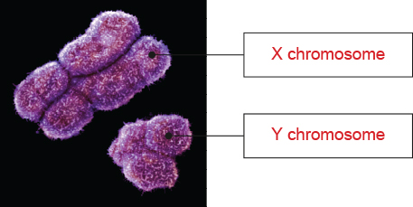

5 What term is used to describe traits and genes that are carried on the sex chromosomes?

Sex-linked

6 Give one example of a trait that is carried on an X chromosome.

Answers will vary but may include sexual characteristics, blood clotting or red–green colour blindness.

7 Match the patterns of inheritance with the correct example.

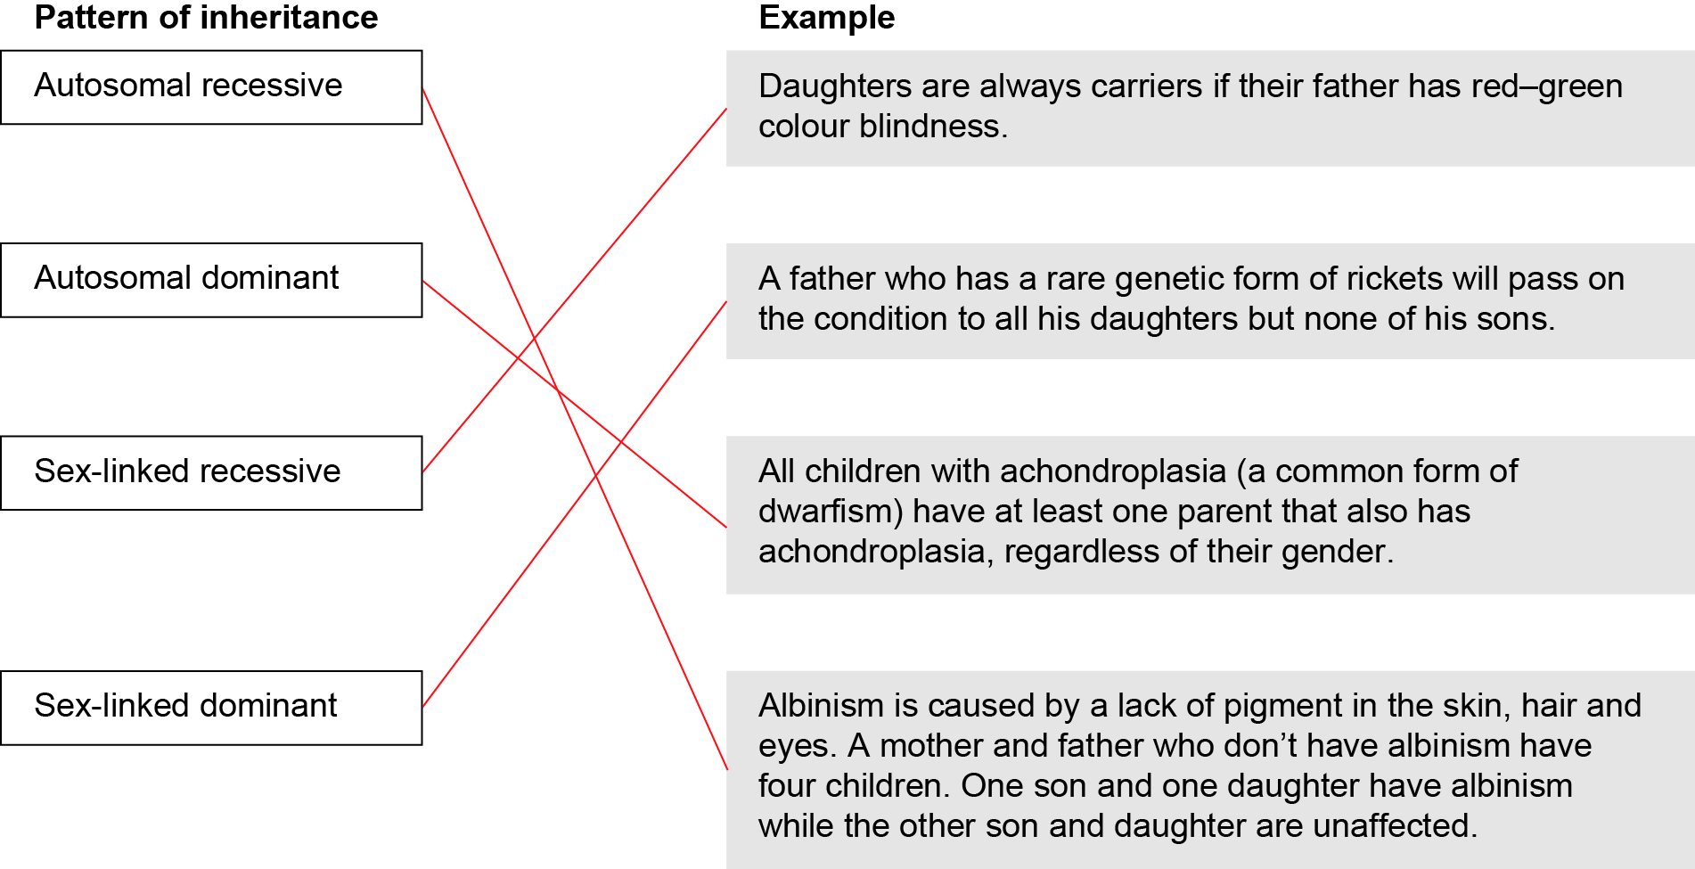

8 What is haemophilia?

A disease that prevents the blood from clotting.

9 If XH is used to represent a normal gene and Xh is used to represent the gene that carries haemophilia, is Alexis carrying haemophilia or does he have haemophilia?

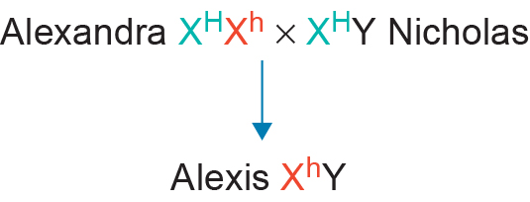

Alexis has haemophilia.

Word detective – Problem solving

10 A man and a woman both have normal sight. They have four children, two boys and two girls.

One of the boys has normal sight and the other is red–green colour blind.

One of the girls has normal sight and the other is red–green colour blind.

Write the genotypes for this family.

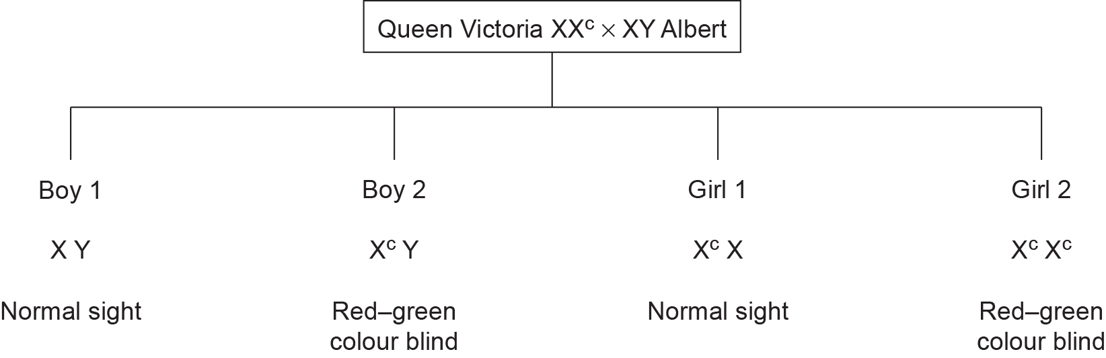

Literacy support worksheet answers

1.9 Inheritance of traits can be shown on pedigrees

Pages 22–25

Pedigrees

1 What does a pedigree show?

A pedigree is a visual way to show how a trait is inherited over two or more generations.

2 Match the following pedigree symbols with the correct meaning.

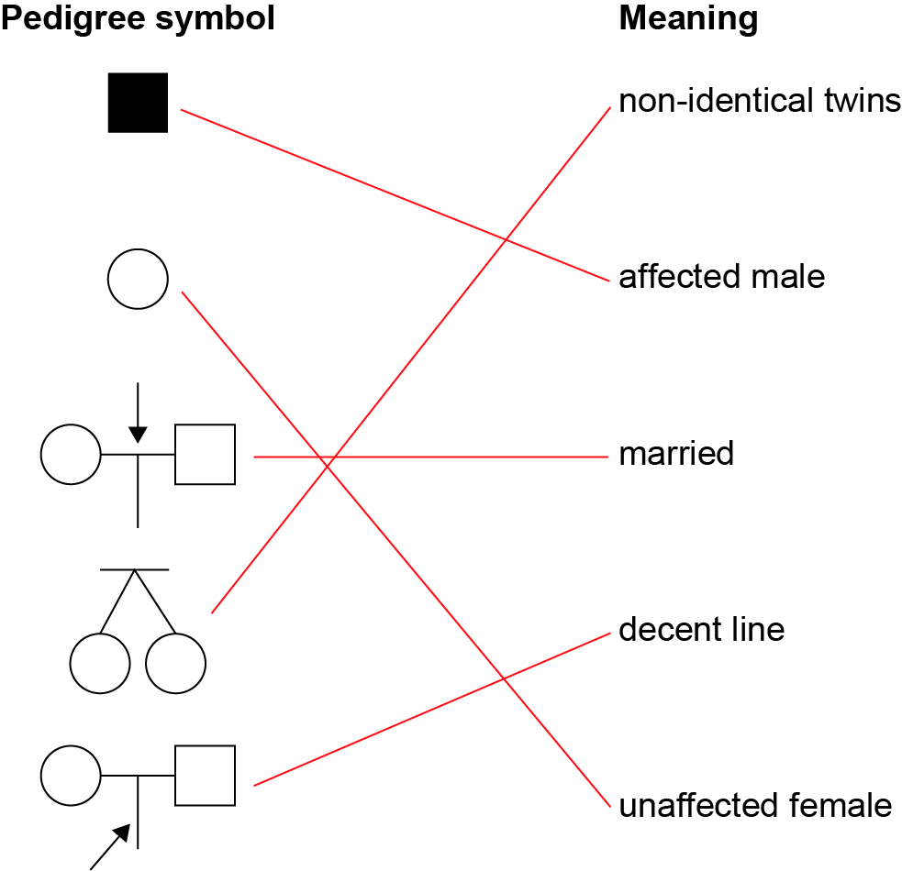

3 What is the symbol in a pedigree for an affected female?

A shaded circle

4 What do Roman numerals represent on a pedigree?

Generation number

5 Use the following word list to fill in the blanks in the passage below.

Word list: characteristic, analysing, recessive, none, children, dominant, dominant, dominant

When analysing a pedigree to determine whether a trait is dominant or recessive, the following rules apply:

• If neither parent has a characteristic and some of their offspring have it, then the characteristic is recessive (i.e. both parents are carrying the allele for the recessive trait but it is not shown in the phenotype).

• If both parents have a characteristic and some of their children have it, then the characteristic is dominant (i.e. both parents are heterozygous).

• If both parents have a characteristic and none of their children has it, then the characteristic is dominant (because, if both parents have a characteristic and it is recessive, then all of their children will have that characteristic because it would have to be on all X chromosomes).

6 The pedigree below shows the inheritance of haemophilia, a sex-linked recessive disease that prevents blood from clotting.

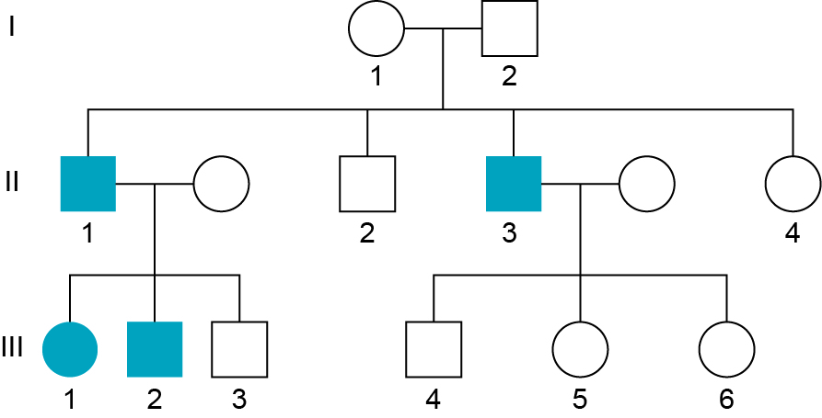

Use the correct symbols to write the genotype of individuals I1 and I2 from the pedigree.

Individual I1: XRXr

Individual I2: XRY

7 Analyse the pedigree below to answer the questions that follow.

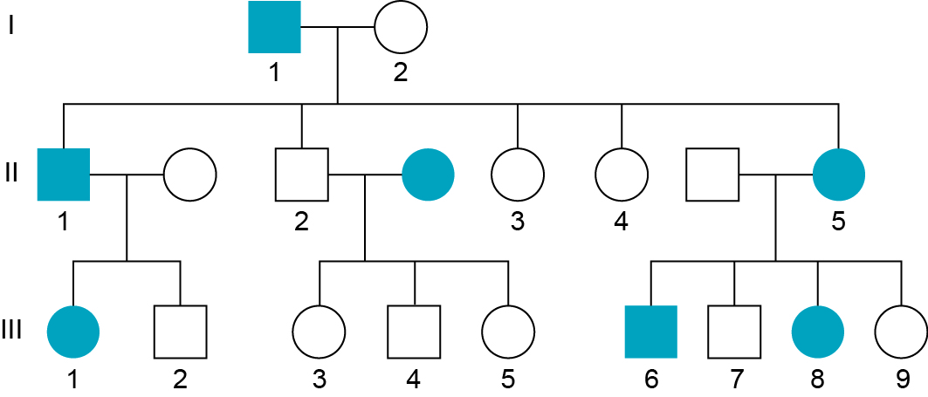

a List the numbers of all the affected males.

I1, II1 and III6

b How many children were born in the second generation?

5

Word detective – Sequencing

8 Pedigrees can be analysed to determine whether an individual will inherit a disease. There are a series of questions you should ask when determining the inheritance pattern from a pedigree.

Use your student book to correctly order the questions from 1–5 to determine inheritance.

4 Has a carrier mother passed it on to half/ some of her sons? YES – Sex-linked recessive

3 Do all affected children have an affected parent? YES – Autosomal dominant. NO, go to 5.

1 Are more males or females affected by the trait? If YES, go to 2. If NO, go to 3.

5 Do affected children have unaffected parents? YES – Autosomal recessive

2 Do all daughters of affected males have the trait? YES – Sex-linked dominant. NO, go to 4.

Literacy support worksheet answers

1.10 Mutations are changes in the DNA sequence

Pages 26–29

Mutations

1 Name three types of substances that can cause mutations in DNA.

chemicals, UV light and cigarette smoke

2 Name three ways a nucleotide can be altered.

substitution, deletion and addition

3 Complete the following table by writing the terms for the definitions in the spaces provided.

|  |  |
| --- | --- |
| Term | Definition |
| Genetic mutation | A permanent change in the nucleotide sequence of a single gene. |
| Mutagen | Environmental factor that increases the frequency of a mutation. |
| Chromosomal mutation | A permanent change in the nucleotide sequence of DNA that affects most of a chromosome. |
| Radiation | Forms free radicles that cause damage to DNA and proteins. |
| Triplet | A group of three bases on DNA. |

4 Use the image below to answer the following questions.

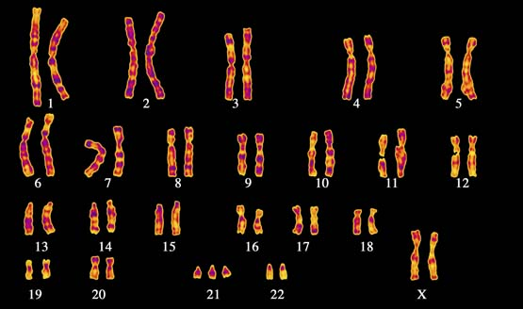

a Which chromosome has had a change in number?

Chromosome 21

b What syndrome does this person have?

Down syndrome

c Is this a chromosomal mutation or a genetic mutation?

Chromosomal mutation

5 What is the effect of non-disjunction in sex chromosomes?

A variety of syndromes

6 Name two types of genetic mutations.

point mutation and frameshift mutation

7 Circle the correct answer for each of the two questions below:

a A point shift mutation:

a always affects the order of amino acids in a protein.

b may not affect the order of amino acids in a protein.

b A frame shift mutation is when:

a a group of three reading frames have been shifted along the DNA strand.

b a substitution that affects the final protein.

8 Use the following nucleotide sequence to answer the questions.

AGG GAT CCG ATA ACC

a Rewrite the nucleotide sequence to demonstrate a mutation where the first thymine is substituted for guanine.

AGG GA**G** CCG ATA ACC

b The sequence change in part a is an example of what type of mutation?

Point/substitution mutation

c Rewrite the original nucleotide sequence to demonstrate a mutation where the first thymine is deleted.

AGG GAC CGA TAA CC

d The sequence change in part c is an example of what type of mutation?

Frameshift mutation

Word detective – True or false

9 Read the statement and circle whether it is true or false.

a ‘Heritable’ refers to the change being passed to offspring. T or F

b DNA replication never makes mistakes. T or F

c Radiation forms free radicals and damages DNA. T or F

d Sickle cell anaemia is a result in a frame shift mutation. T or F

e Point mutations have more damaging effects than frame shift mutations. T or F

f Some chemicals insert into DNA instead of bases, causing damage. T or F

g Non-disjunction can occur in sex chromosomes. T or F

h Deletion of a base to a chromosome causes more damage than substitution. T or F

Literacy support worksheet answers

1.11 Genes can be tested

Pages 30–31

Genetic screening and testing

1 What can be used to bind the alleles of individuals at risk of genetic diseases?

Probes

2 Genetic testing can currently be carried out on people at risk for which genetic diseases or conditions?

• breast cancer

• cardiovascular disease

• Alzheimer’s disease

(Note: Other answers are possible.)

3 State which type of cells DNA is taken from and why.

White blood cells because red blood cells do not contain DNA.

4 Fill in the table below to show the different genetic screening and testing services currently available in Australia.

|  |  |  |
| --- | --- | --- |
| Genetic screening and testing | What individuals are screened? | An example of a disease, disorder or defect being screened |
| Maternal serum screening (MSS) | Pregnant women | Down syndrome, neural tube defects |
| Newborn screening | Newborn babies | Phenylketonuria (PKU), hypothyroidism, cystic fibrosis |
| Early detection and predictive testing | Adults | Cystic fibrosis, Huntington’s disease |

5 Name two ethical issues with genetic screening.

• Who should access the information

• Possible misuse of information

Word detective – Complete a PMI chart

6 Complete a PMI (Plus, Minus, Interesting) chart for genetic testing by copying the appropriate sentences under each heading.

Write a P for Plus, a M for Minus or an I for Interesting to indicate where the sentences or questions should go in the table, then write them in the correct place in the table.

M What are the risks of the tests that they are prepared to take?

I The tests may not be accurate.

P Minimises the frequency of the diseases in future generations.

P Increases early diagnosis.

I The testing may not pinpoint the impact of the mutation on the baby.

M What options are available if it is not good news?

M If I am a carrier, should I have kids if they may have a genetic disease?

I If the tests are not correct, this may impact parent decisions.

P Increases early intervention to help those with genetic diseases

**Genetic Testing**

|  |  |  |
| --- | --- | --- |
| Plus | Minus | Interesting |
| Increases early diagnosis. | If I am a carrier, should I have kids if they may have a genetic disease? | The tests may not be accurate. |
| Increases early intervention to help those with genetic diseases. | What are the risks of the tests that they are prepared to take? | If the tests are not correct, this may impact parent decisions. |
| Minimises the frequency of the diseases in future generations. | What options are available if it is not good news? | The testing may not pinpoint the impact of the mutation on the baby. |

Literacy support worksheet answers

1.12 Genes can be manipulated

Pages 32–33

Manipulating genes

1 Name the four nucleotides that allow DNA to be transferred.

A, T, C and G

2 Write the terms for the definitions in the table below:

|  |  |
| --- | --- |
| Term | Definition |
| Genetically modified organism | Organisms that have had their DNA altered to enhance desirable traits |
| Transgenic organism | Organisms that have had DNA from a different species incorporated into their genome |
| Genome | The entire set of DNA of an organism |
| Biodiversity | All the different species within a particular area |

3 Name three advantages of GM food, plants and animals.

• Plants that are resistant to herbicides and pesticides

• ‘Pharm’ plants and animals that produce pharmaceutical proteins for humans

• Plants that are resistant to disease

4 What are some possible disadvantages of GM foods?

• They replace many natural varieties with one variety.

• GM foods may pose health risks.

• GM plants may contaminate non-GM plants.

5 Why might a farmer want to grow GM crops?

Farmers use less pesticide reducing production costs.

6 How is this good for the environment?

Less pesticides and herbicides reduce environmental pollution.

Word detective – Draw and label

7 Draw a series of labelled diagrams to show how a soybean plant can become drought resistant through genetic modification. (Hint: You can use Figure 1.57 in the student book to help you.)

Student diagrams will vary but should show:  
gene from DNA isolated from sunflower → gene placed in plasmid → plasmid placed in bacterium → bacterium added to embryonic soybean plant → embryo develops into transgenic soybean plant

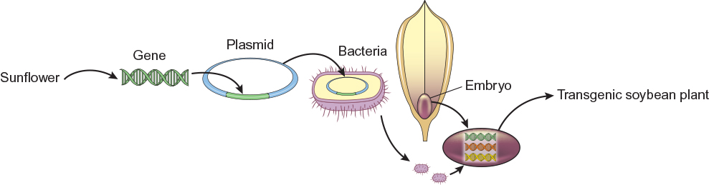

Literacy support worksheet answers

1.13 Genetic engineering is used in medicine

Pages 34–35

Genetic engineering

1 What is genetic engineering?

Genetic engineering is the process of changing the genetic code of an organism.

2 What is gene cloning?

Gene cloning is inserting a gene into bacteria so the bacteria can now produce a human protein to treat a disease.

3 Fill in the blanks in the flow diagram below, describing how gene therapy has been used in the treatment of cystic fibrosis.

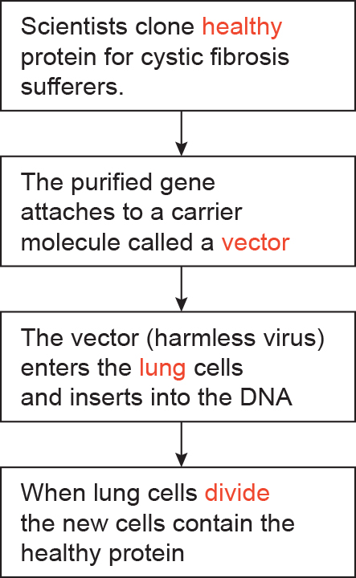

4 Name five types of illnesses that induced pluripotent cells could be used to help in the future.

• Cancer

• Multiple sclerosis

• Parkinson’s disease

• Motor neuron disease

• Spinal cord injuries

5 Write the type of stem cell for each of the definitions in the following table.

|  |  |
| --- | --- |
| Type of stem cell | Definition |
| Pluripotent embryonic | Stem cells obtained from embryos that can develop into most cell types in the body. |
| Multipotent adult | Stem cells obtained from body cells that can only develop into certain cell types in the body. |
| Induced pluripotent | Multipotent adult stem cells that have been turned back into pluripotent cells. |

Word detective – Sequencing

6 Place the following gene-cloning steps in the correct order by labelling the diagrams as 1–5.

|  |  |  |  |  |
| --- | --- | --- | --- | --- |
| L:\1. Publishing and Editorial\1. Product\Oxford Science\Oxford Science 10\3. Extras\6. Student worksheets\Artwork\4. Final jpgs\SW0132_01095.jpg | L:\1. Publishing and Editorial\1. Product\Oxford Science\Oxford Science 10\3. Extras\6. Student worksheets\Artwork\4. Final jpgs\SW0133_01095.jpg | L:\1. Publishing and Editorial\1. Product\Oxford Science\Oxford Science 10\3. Extras\6. Student worksheets\Artwork\4. Final jpgs\SW0134_01095.jpg | L:\1. Publishing and Editorial\1. Product\Oxford Science\Oxford Science 10\3. Extras\6. Student worksheets\Artwork\4. Final jpgs\SW0135_01095.jpg | L:\1. Publishing and Editorial\1. Product\Oxford Science\Oxford Science 10\3. Extras\6. Student worksheets\Artwork\4. Final jpgs\SW0136_01095.jpg |
| 4 | 2 | 5 | 1 | 3 |